ISABEL MANZONI

Classificazione dataset

<http://sdg4-data.uis.unesco.org/>

Classificazione

Licenza BY

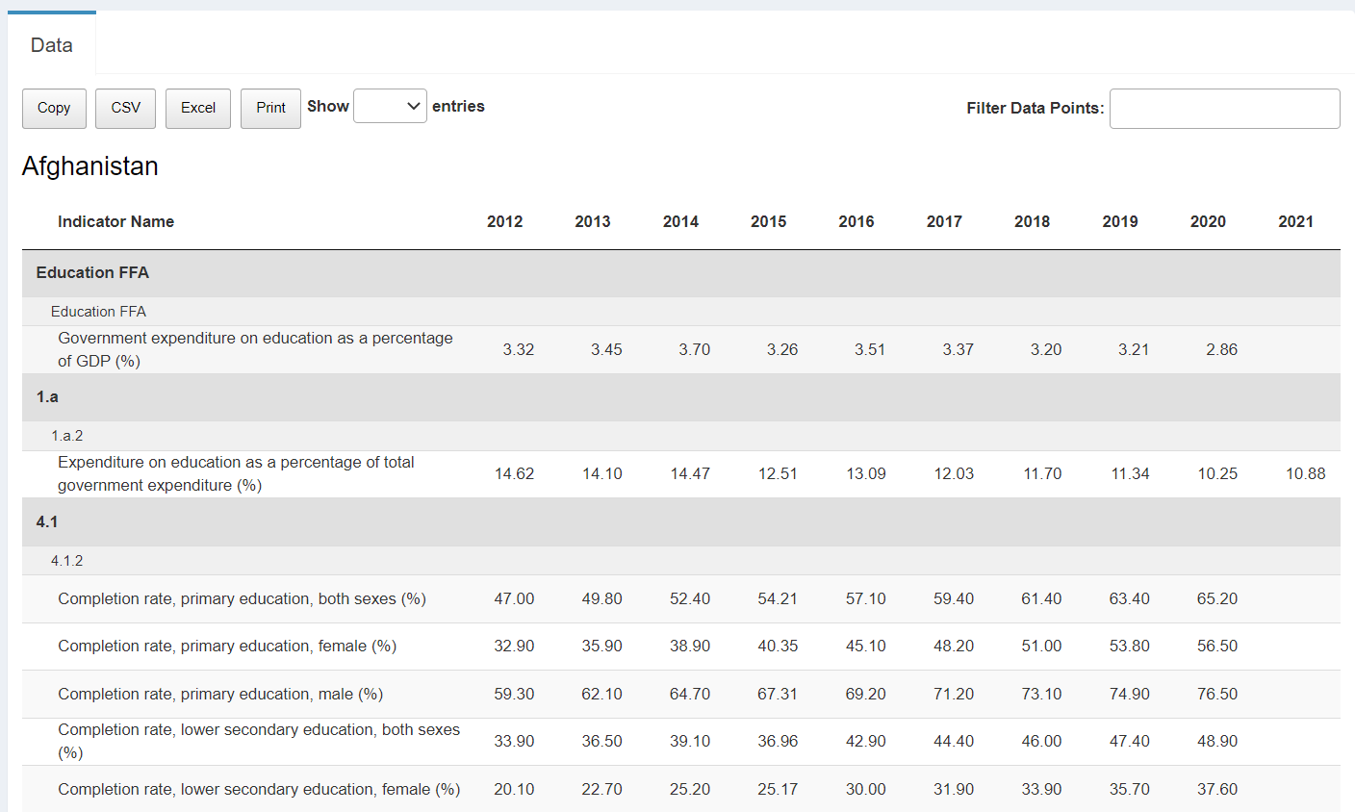

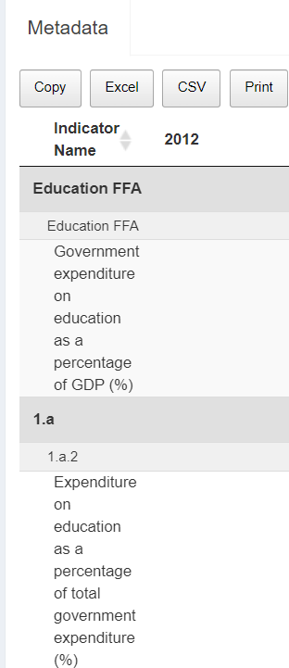

<https://healthdata.gov/National/School-Learning-Modalities/aitj-yx37>

Classificazione

Licenza --

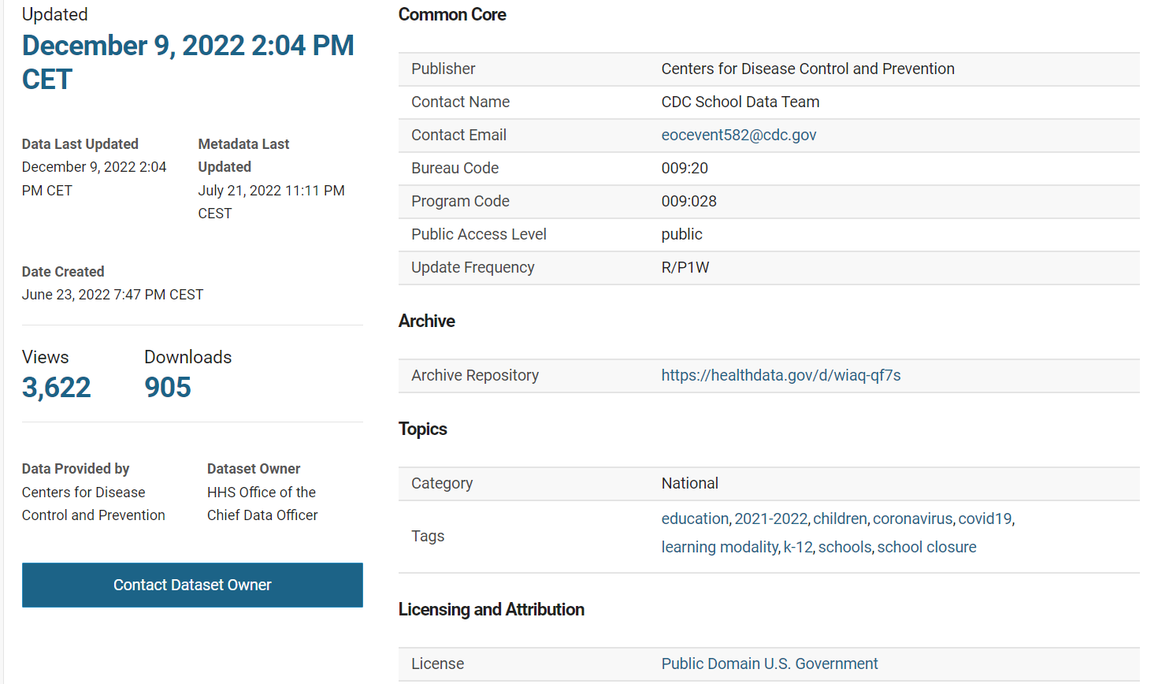

<https://dati.lombardia.it/>

Classificazione

Licenza BY

Sindaci Comuni Lombardi:

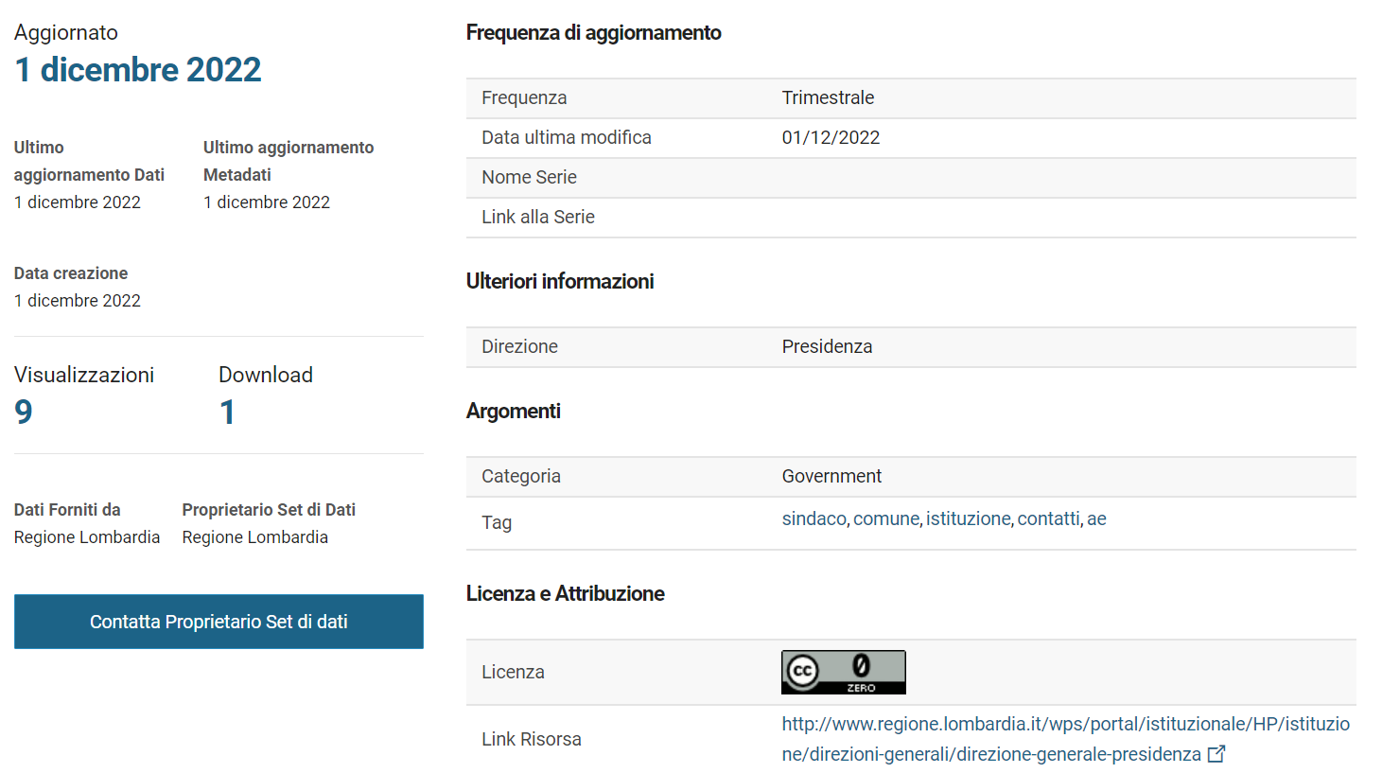

<https://www.kaggle.com/datasets/whenamancodes/adidas-us-retail-products-dataset> :

<https://www.kaggle.com/datasets/whenamancodes/adidas-us-retail-products-dataset>

Licenza CC

Classificazione

Metadata:

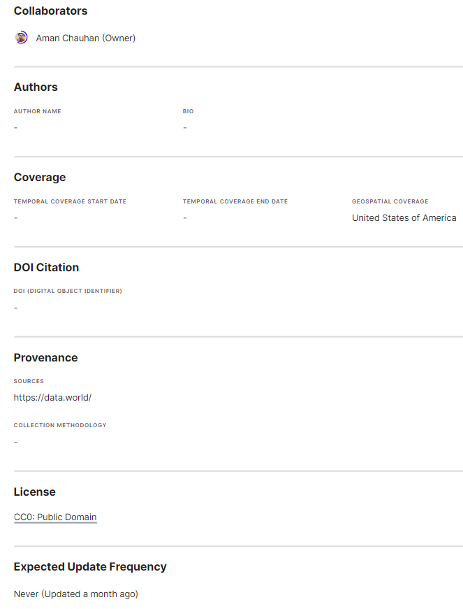

<https://www.kaggle.com/datasets/whenamancodes/adidas-us-retail-products-dataset> :

<https://www.kaggle.com/datasets/thedevastator/new-dataset-of-celebrity-deaths-in-2016>

Licenza --

Classificazione

Metadata:

